German Unification Under Otto Von Bismarck

From 1862 to 1890, Otto Von Bismarck was the Prime Minister of Germany. He unified the different German states (previously, they had been joined together as the Holy Roman Empire) by using the military.

Excerpt from Otto Von Bismarck’s “Blood and Iron” Speech (1862)

The position of Germany will not be determined by its liberalism but by its power ... [Germany] must concentrate its strength and hold it for the favorable moment...Since the treaties of Vienna [after Napoleon was defeated in 1814], our borders have been ill-designed. Not through speeches and majority decisions will the great questions of the day be decided, but by iron and blood.

Central Europe in 1870

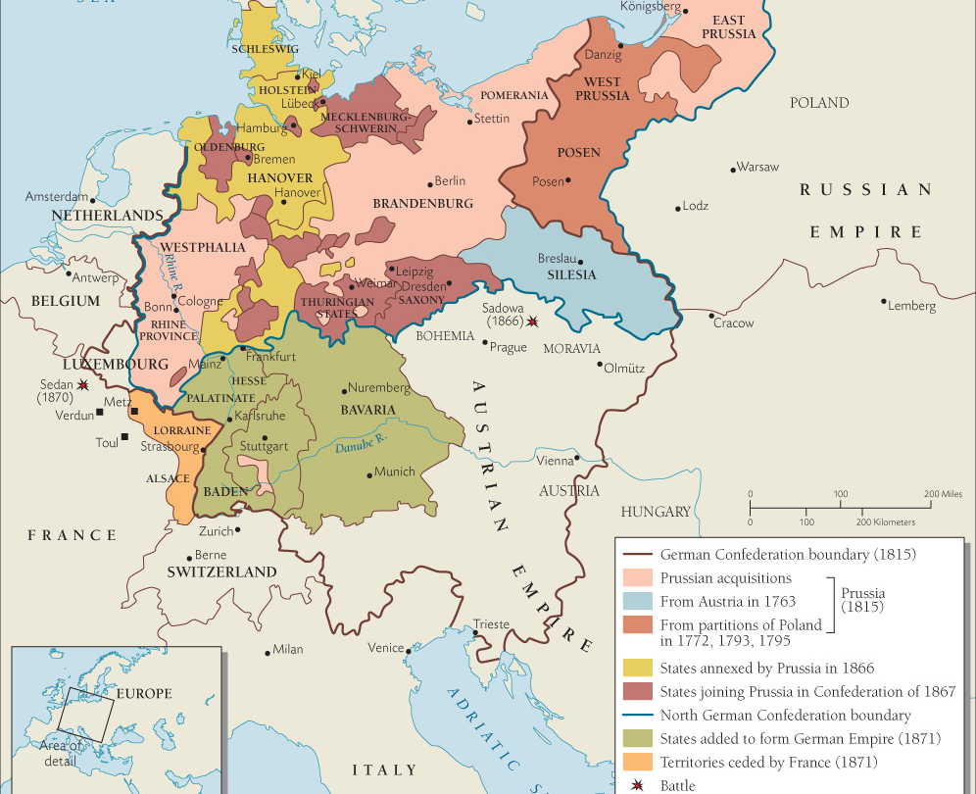
Questions:

- Based on the map, what powerful empires surrounded all the German states?

- How could it benefit the German states to unify into one nation called Germany?

- Based on the excerpt from Otto Von Bismarck’s speech, what do you think he means by blood and iron? Explain why you think so.

