Three Estates of France

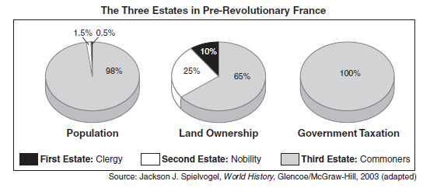

Based on the Graphs what conclusions can be drawn about?
- Society

- Government

- Economy

